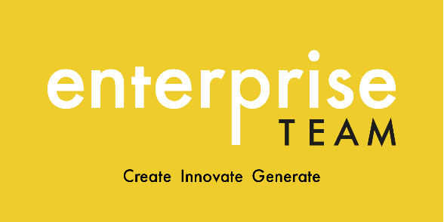
Workbook & Journal

Enterprise Residency for Business/Project work

Whilst not assessed, this workbook and journal can be submitted at the end of the programme to support your work. Your answers can be in any form (written; audio; video; mind-map etc.) and as such you do not need to use this document exclusively.

This workbook journal includes a range of thought-provoking questions which will help you develop an idea in a way that is both realistic and achievable.

Contents

- About you

- About your idea

- About your target audience

- Competition

- Journal

About you
What personal interests do you have? | You may be able to align something you are interested in with your business/project idea. See the next question.
How can you integrate your interests into your project?
What are your core values (what do you stand for)? | Also consider how you can align your values with those of your target audience.
Which of your personal attributes do you feel could hinder you most in your project? | Consider how you can counteract this, and the consequences if you don’t.
Is your idea concept only or do you want to take it forward into summer and beyond?
What do you want from this?

About your idea
In one sentence, explain your idea
Are you solving a problem? | Please elaborate.
Who is it for? | Give a brief overview of your target audience. You can elaborate on this in the Target Audience section.
What is the minimum viable size of your market? | Consider how many people do you need to engage with your idea initially to gain traction.
What is your USP (unique selling point?)
Why do you think your idea will be successful?
How will you evidence that your idea is likely to work? | This is the most important question and will indicate how viable your idea actually is.
What do you need to get started and what are the associated costs, if any?

About your target audience.
The following questions address both demographics (defining audiences by factors such as age, gender, marital status, income, etc.) and psychographics (the characteristics of an audience that are slightly more intangible, such as interests, habits, attitudes, emotions, and preferences).
Gender
Age
Job type
Income bracket
Homeowner or rental etc.
Relationship status
Children?
Pets?
Country and Region
Social media platforms they use
Personality type
Favourite brands
Where they shop
Their values

About your competition (duplicate this section for each different key competitor. Pick at least 3)
Name of competitor
Employee size
How long have they been running?
Who do they sell to and in which geographical locations?
On which platforms do they sell and promote themselves?
What is working well?
What isn’t working well?
How will you differentiate yourself from them?

Journal

You are advised to complete this regularly, although you decide the frequency.

Date:
This week I have achieved:
My biggest challenges this week has been:
This week I have learnt:
I need support with:
My goals for next week are:

